6.59: a) Moving a distance L along the ramp, 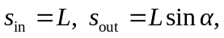 so 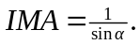
b) If 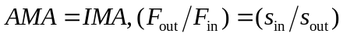 and so 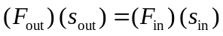, or 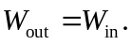
c)
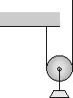
d)
